WAP for printing all natural numbers till 20.

#include <iostream>

using namespace std;

int main()

{

int sum=0;

for(int i=1;i<=20;i++)

{

sum=sum+i;

}

cout<<sum<<endl;

return 0;

}

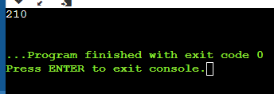

2-WAP for printing all natural numbers in reverse order starting from 20.

#include <iostream>

using namespace std;

int main()

{

int i;

for(i=20;i>0;i--)

{

cout<<i<<endl;

}

return 0;

}

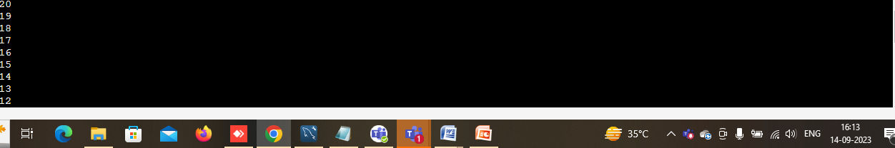

3-WAP for printing all even numbers from 1 to 20.

#include <iostream>

using namespace std;

int main()

{

int i;

for(i=1;i<=20;i++)

{

if (i%2==0)

cout<<i<<endl;

}

return 0;

}

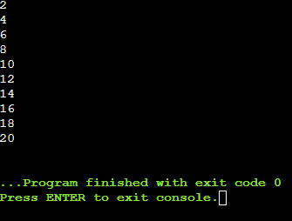

4-WAP for printing all odd numbers from 1 to 20.

\*\*\*\*\*\*\*\*\*\*\*\*\*\*\*\*\*\*\*\*\*\*\*\*\*\*\*\*\*\*\*\*\*\*\*\*\*\*\*\*\*\*\*\*\*\*\*\*\*\*\*\*\*\*\*\*\*\*\*\*\*\*\*\*\*\*\*\*\*\*\*\*\*\*\*\*\*\*\*/

#include <iostream>

using namespace std;

int main()

{

int i;

for(i=1;i<=20;i++)

{

if (i%2!=0)

cout<<i<<endl;

}

return 0;

}

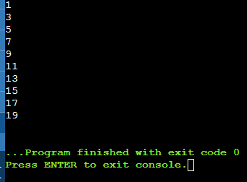

5-WAP for adding all numbers from 1 to 20.

#include <iostream>

using namespace std;

int main()

{

int sum=0;

for(int i=1;i<=20;i++)

{

sum=sum+i;

}

cout<<sum<<endl;

return 0;

}

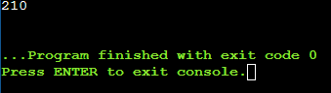

WAP for finding sum of all even numbers till 20.

#include <iostream>

using namespace std;

int main()

{

int i=1,sum=0;

while(i<=20)

{

if(i%2==0)

sum+=i;

i++;

}

cout<<"the sum all even numbersfrom 1 to 20 is:"<<sum;

return 0;

}

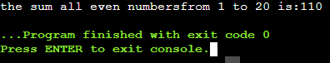

WAP for finding sum of all odd numbers till 20.

#include <iostream>

using namespace std;

int main()

{

int i=1,sum=0;

while(i<=20)

{

if(i%2!=0)

sum+=i;

i++;

}

cout<<"the sum all even numbersfrom 1 to 20 is:"<<sum;

return 0;

}

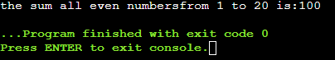

8-WAP for printing multiplication table of a number. For eg. Display should be “ 2 X 1 = 2”

#include <iostream>

using namespace std;

int main()

{

int i=1,sum=0,n;

cout<<"enter the number for getting it multiplication table:";

cin>>n;

while(i<=10)

{

cout<<n<<"\*"<<"="<<n\*i<<endl;

i++;

}

return 0;

}

